MOONWHIZZ

INDEPENDENT LAND ROVER SPECIALISTS

SPECIAL OFFERS Oct 2013

SERVICES

1) Air Spring Replacement for Range Rover

* Main Dealer price £1400 inc parts
* Moonwhizz price £1100 inc parts

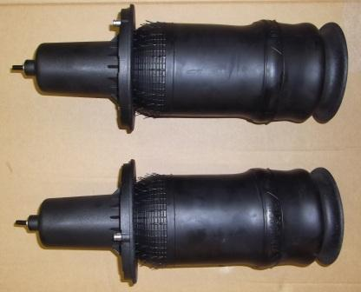

£75.99

+VAT

P38 Front Air Springs - DUNLOP £75.99 +Vat Each or FITTED for

£235.00 +Vat for both Front Air Springs and Fitting kit included.

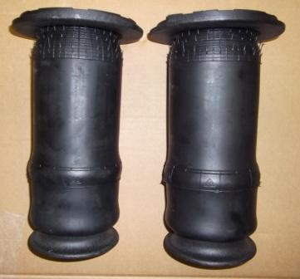

P38 94-02 Rear Air Springs - DUNLOP £76.99 +Vat Each

or FITTED for £235.00 +Vat for both Rear Air Springs and Fitting kit included.

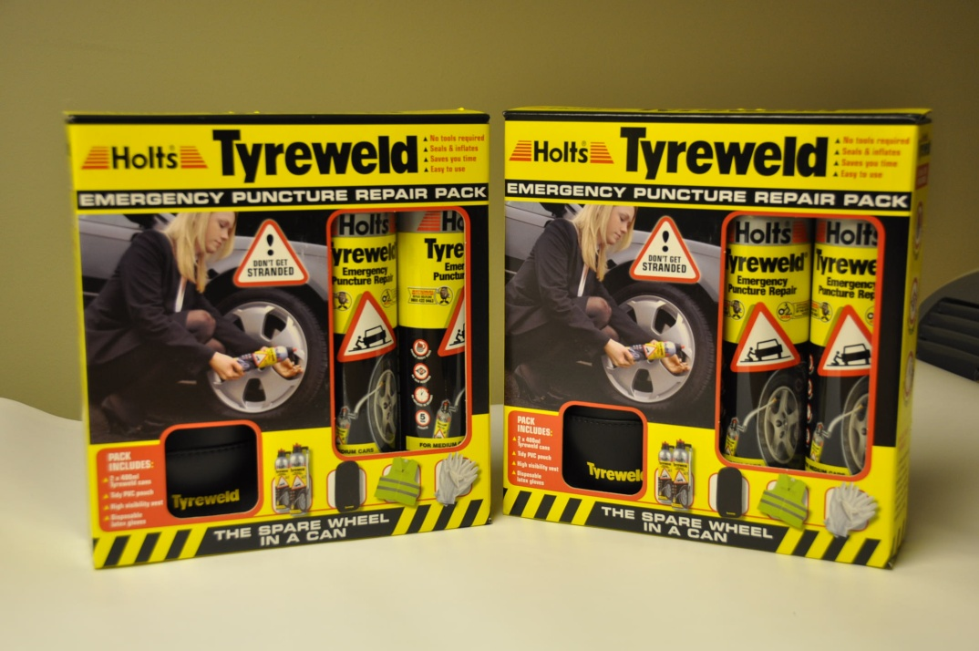

£11.99

+ Vat

Holts Tyreweld - EMERGENCY Puncture Repair Pack

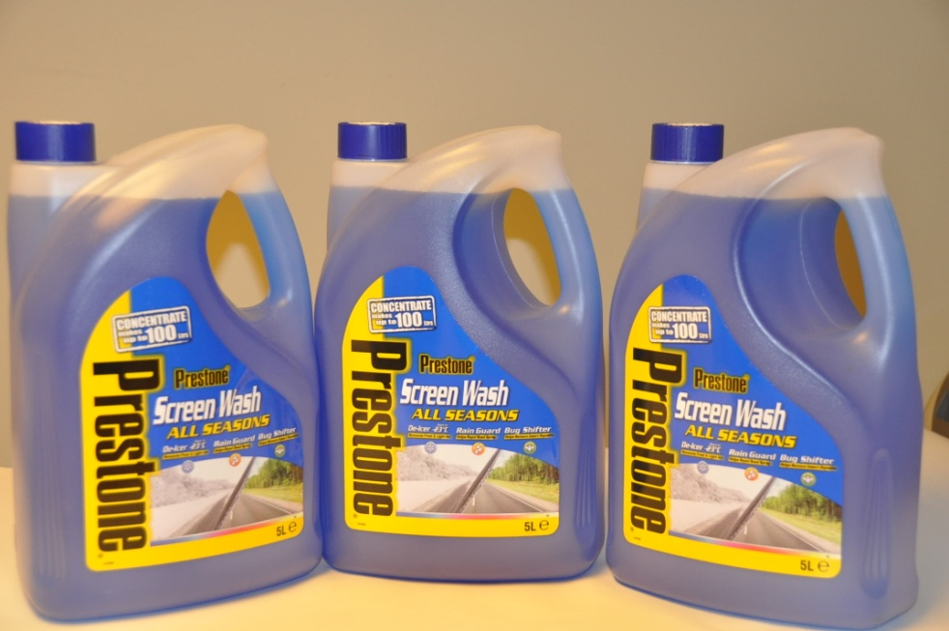

£5.99

+Vat

Prestone 5 Litre Screen Wash - ALL Seasons

Great Value just £5.99 +Vat each.

£12.99

+Vat

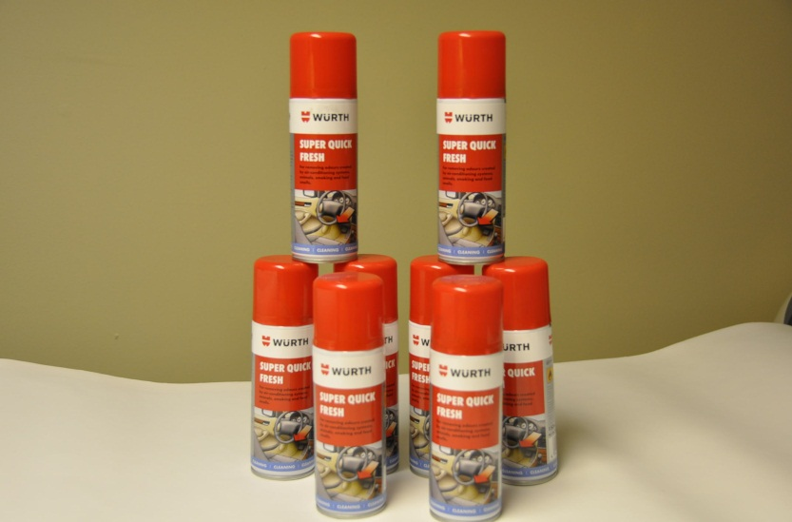

Smelly Air -Con System ?

Why not let us disinfect your Evaporator and stop those

nasty smells for just £12.99+Vat.

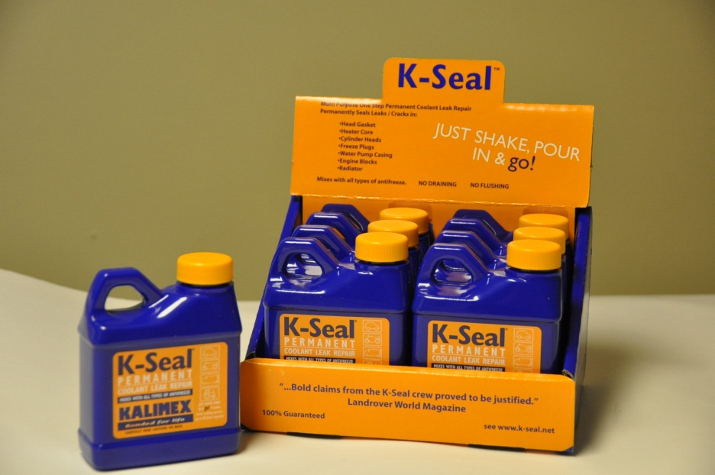

£9.99

+Vat

Leaking Radiator, Water Pump, Heater Matrix why not try K-Seal?

A permanent fix for all makes of car.

£9.99

+Vat

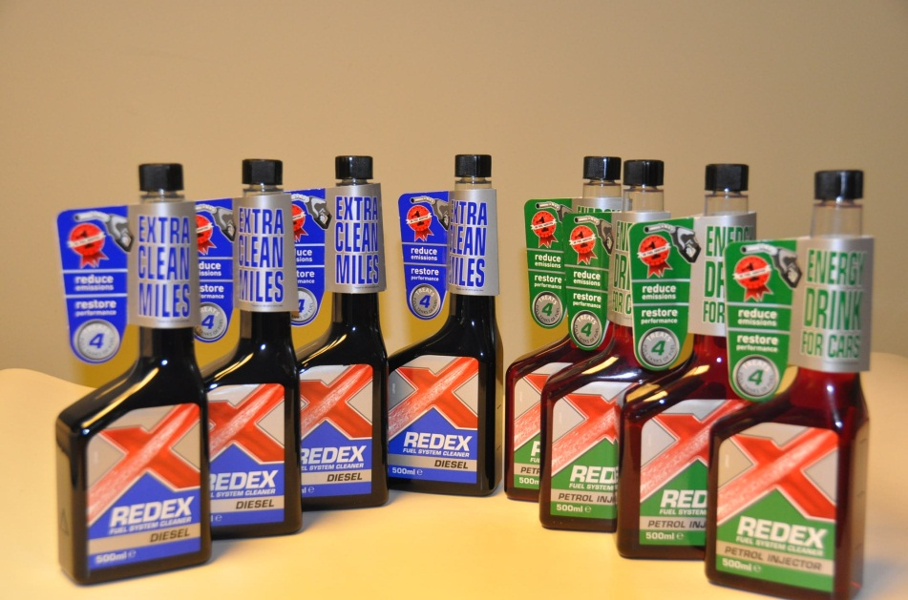

Redex Diesel and Petrol Injector Cleaner, helps Reduce Emissions

and Improve Performance

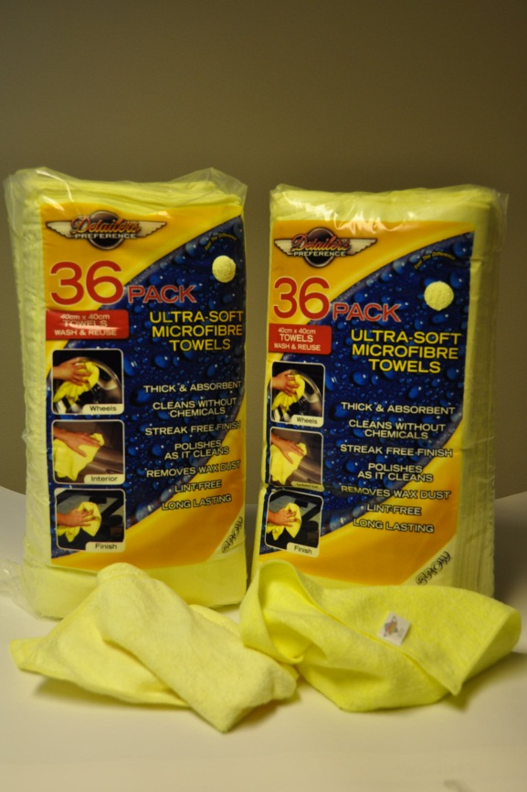

£15.99+Vat

Thick & Absorbent 40cm x 40cm

Ultra-Soft 36 pack Microfibre Towels

Out-standing value.

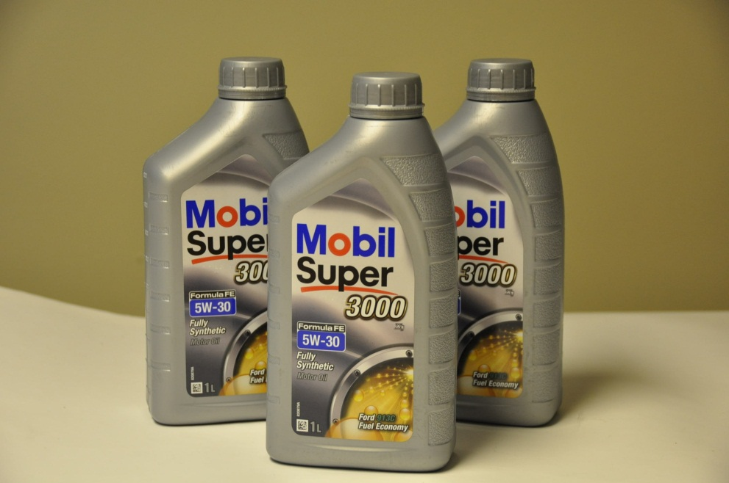

£9.99

+Vat

As a Mobil 1 Service Centre, we can pass on excellent discounts

on one of the worlds best oils .

£7.99+Vat

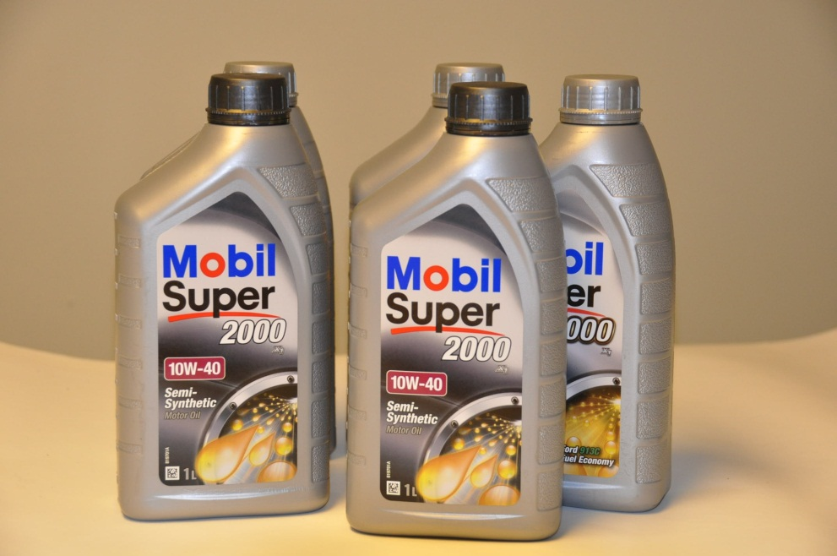

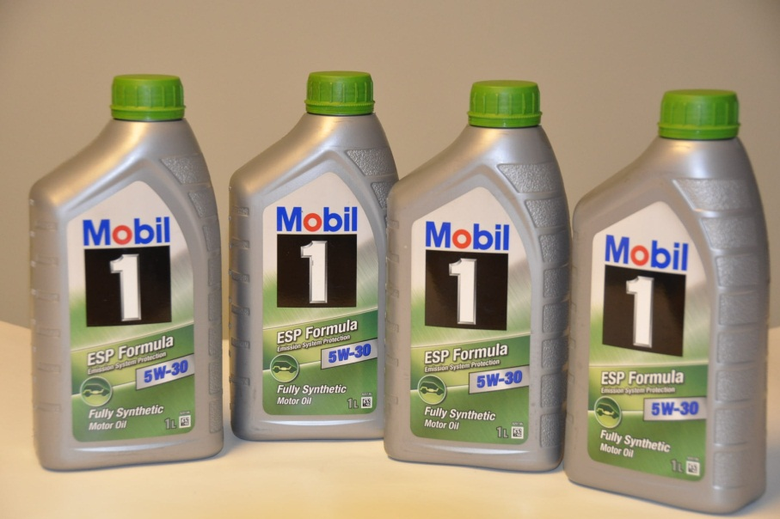

£14.39

+Vat

£0.96

+vat

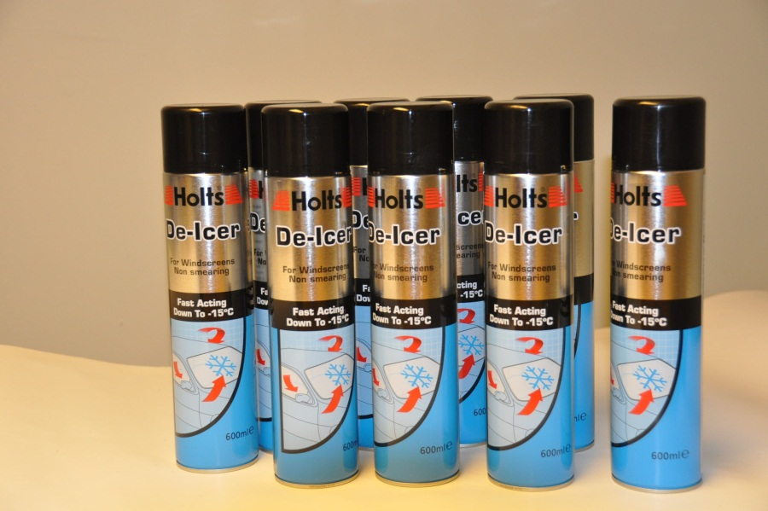

Large 600ml Holts Fast Acting De-Icer down to -15C

FITTING KIT

£2.00 +Vat

